How to find COVID-19 Smart Restart products

To assist with completing the Smart Restart Covid-19 PPE & Supplies Order Form, you can find and view the COVID-19 Smart Restart products on the Shop@UW website 2 different ways. By looking the product up directly with the item number below:
Item Number | Description
EOC-TBQUAT | TB Quat Disinfectant Spray - 1 Qt Bottle
EOC-TX650 | TexQ Disinfectant Spray Bottle Quaternary Ammonium
EOC53400 | VWR Face Shield - 50/pack
EOC7987212 | Face Shield - Disposable - 24/box
EOCDPPS | Face Shield - DPPS - 5/PK
EOCPT-L | Premium Touch Nitrile Gloves Large - 100/box
EOCPT-M | Premium Touch Nitrile Gloves Medium - 100/box
EOCPT-S | Premium Touch Nitrile Gloves Small - 100/box
EOCPT-XL | Premium Touch Nitrile Gloves Extra Large - 100/box
EOCVWR-L | VWR Nitrile Gloves Large - 100/box
EOCVWR-M | VWR Nitrile Gloves Medium - 100/box
EOCVWR-S | VWR Nitrile Gloves Small - 100/box
EOCVWR-XL | VWR Nitrile Gloves Extra Large - 100/box
EOCVWR-XS | VWR Nitrile Gloves Extra Small - 100/box
EOC99104 | Ad Madison 4-ply fabric face mask
EOCSTD100G-S | Fabric Mask-UltraSmall Grey - 200/PK
EOCSTD100LG-L | Fabric Mask-Ultra Large Grey - 200/PK
EOCSTD100W-L | Fabric Mask-Ultra Large White - 200/PK
EOCSTD100W-S | Fabric Mask-Ultra Small-White - 200/PK
EOC-INF091056 | Procedure Masks (medical) - 3-ply - 50/BOX
EOCGPMASK | Gen Purpose Procedure Mask - 50/BOX
EOC7127351 | Germ Buster 80% Hand Sanitizer 1.68oz - 10/CS
EOC15029564 | Hand Sani - Enpac 8oz - EACH

Or by doing the following search:
- Search “Smart Restart” in the Shop@UW search bar.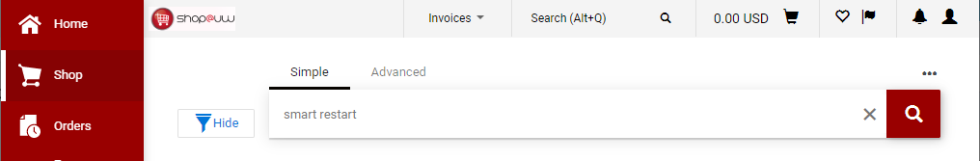

- Apply the appropriate filter on the left side of your screen.
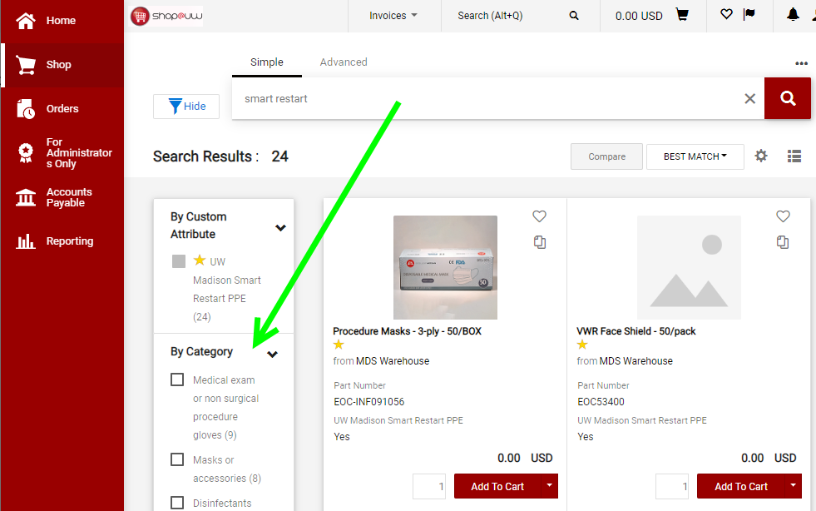
- The page should now show filtered results that are from the MDS Warehouse at no cost to your funding string.
